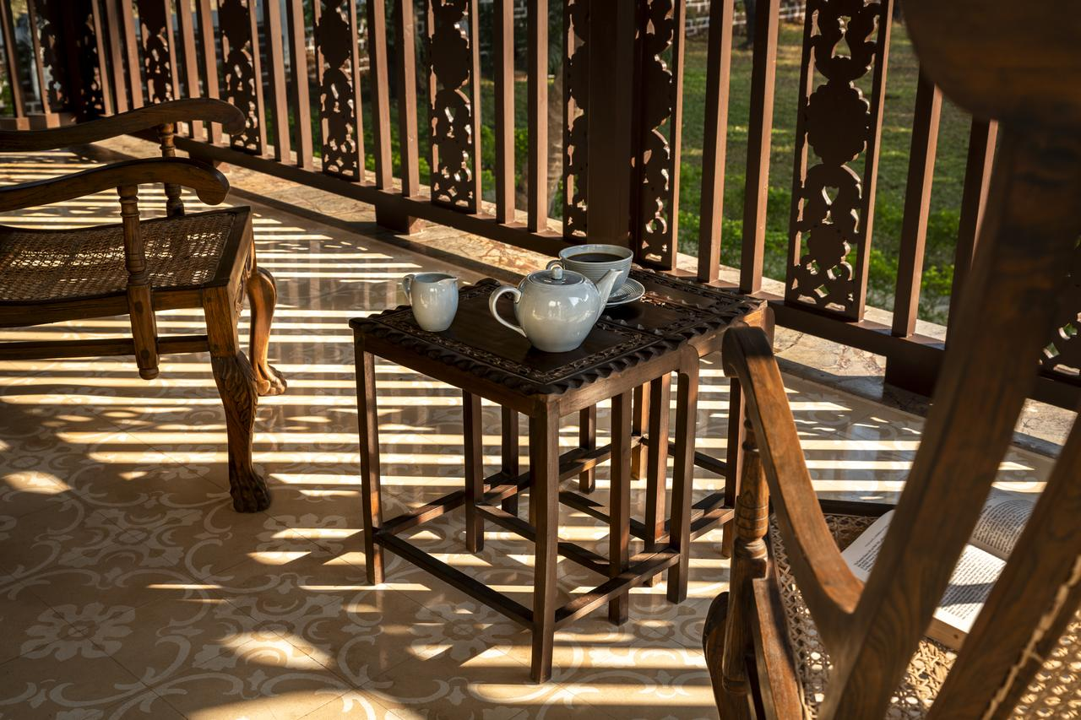
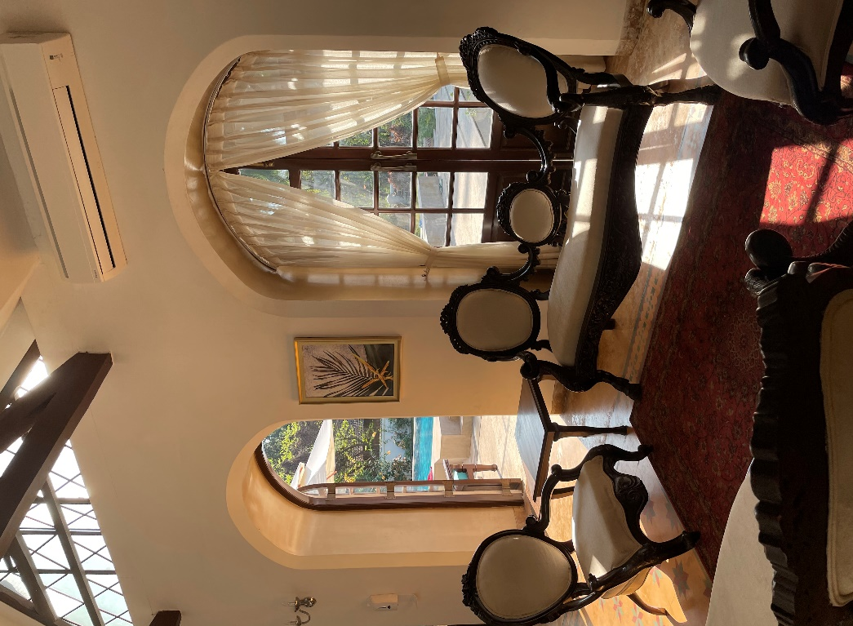
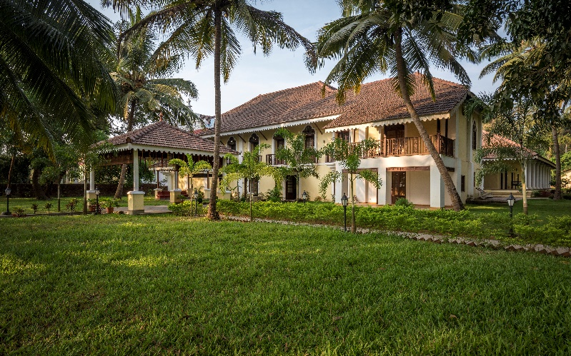
The Postcard Hotel
The Postcard is a collection of intimate luxury hotels hidden in holiday destinations across India and the world. It recalls an era when holidays were sun-kissed and still, where the days were spent idling and flipping through old magazines, against the backdrop of charming, quiet neighbourhoods. In that spirit, The Postcard combines luxury with simplicity, helping you retreat to a life you’ve always wanted — simple, unhurried and filled with rich, little discoveries.

